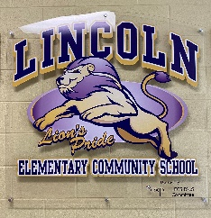
Principal: Fern Touchie Instagram: @lincolnlions2021
Administrative Assistant: Susanna Withers Twitter: @lincolnlion2021 Phone: 357-4075 Website: http://lincoln.nbed.nb.ca

Lions’ Pride. Lead and Learn with the Lincoln Lions
_____________________________________________________________________________________________
September 2021
- School Hours - Our school opens, with staff supervision, at 7:40 am daily with busses arriving. Daily dismissal Mon-Thurs is 1:30pm (K-2) & 2:30pm (Gr 3-5) and Fridays at 11:30am (all students).
- Bus Loading Zone – We have noticed over the last week some congestion particularly at drop off times and this in part due to the schedules of the buses. We are asking currently to not use the bus loading zone before 8 am in the morning for drop off. Buses sometimes run late and when they arrive, they cannot have vehicles in their lane for unloading as it is unsafe. We ask that if you are dropping off your child in the mornings that you avoid entering the bus drop off zone and drive down to the left along the sidewalk parking as far down the sidewalk as possible so that several cars can unload at a time. We will try to have staff out directing traffic. Thanks for your understanding.
- Buses – Bus drivers are trying to get to know their routes and students on their bus. Sometimes district transportation needs to make changes and do their best to notify families and the school. We have been notified that Bus #381 will not be operating Mon-Thurs. Stacey Grimm’s bus #374 will be taking students along the Lincoln Road, from Story Crt to Nevers Rd. Lisa Agnew’s bus #301 will be taking students to Tamarack Trailer Park, Lincoln Gardens, etc. Friday buses have a different route as well since they are taking all K-5 at one dismissal. Please make sure that your child’s teacher knows exactly where your child is going each day (bus, pickup, daycare) as early as possible. A consistent schedule works best for both teachers, bus drivers and caregivers if possible.
- Parent Contact Information – Student Demographic forms were sent home for you to make any changes. Please make sure these are returned to school ASAP. For the safety of your child, we must be able to reach you throughout the school day.
- Safe Arrival - Please call the school (357-4075) and leave a message if your child will be absent from school. Otherwise, you will receive a call from the school. Thanks!
- Visitors - Due to district protocol, the school is limiting visitors. Parents will not be allowed to enter the building without a scheduled appointment. If you need to drop something off at the school for your child, our admin assistant will meet you at the door. Should you enter the school for an appointment you are required to wear a mask. Thank you for your understanding as we work through these unprecedented times.
- Severe Allergies - We have a severe nut and egg allergy in our building this year at LECS. A letter was sent home to parents with information. Please ensure that you read the letter and return to the school signed.
- Virtual Meet the Teacher – You child’s teacher will be sending you information on the Meet the Teacher virtual format for this year.
- PALS - Our “Parents Assisting Lincoln School” Committee is always looking for additional volunteers. This fabulous group of volunteers plan and organize fundraising and other activities for our school. Everything they do benefits our students! If you are interested, please reach out to the school.
- PSSC - The Parent-School Support Committee is a group of committed volunteers who work with the Principal on the School Plan to help make our school a great place to be. We will be seeking parents to join our PSSC this year! If you are interested, please reach out to the school.
- Curious Kids Child Care is a private childcare service that operates in Lincoln Elementary. They offer full time and part time services for children ages 3 – Grade 5 to meet the childcare, preschool, and afterschool needs of our families.
- BUSPLANNER - Just a reminder that if your child goes on a bus you can sign up for notifications through Busplanner (https://asdsbp.nbed.nb.ca/). This email service will provide you with up-to-date information about bus delays and cancelations.
- Sickness - if your child is sick please keep them home to get well. If you child develops 2 or more COVID symptoms at school, you will be called to pick up your child ASAP.
- Appropriate Clothing - Students will have daily outdoor time as long as the weather cooperates. Please dress students according to the weather to ensure that they have the best experience possible during our outdoor recess time.

DAtes to Remember
Terry Fox Walk – Sept 29th
National Day for Truth & Reconciliation (Orange Shirt Day) – Sept 30th
School Picture Day – Oct 5th
Thanksgiving day (No School) – Oct 11th
Kindergarten REgistration Week (students enterning Fall 2022) – Oct 12 – 15th

Guidance Corner
My name is Kristie LaBrecque and I am the Guidance Counsellor at Lincoln Elementary on Wednesdays and Friday mornings. This is my first year at this school and I look forward to connecting with the many students and families at LECS!

I work with students and staff in many ways. I offer one-to-one meetings to help students with their social skills, emotional needs and positive behavior strategies while also creating small group workshops for students dealing with similar issues. Promoting community and wellness education within our school is very important in this role, and I often collaborate with teachers to support these initiatives.

I encourage communication with our families and will always respond to emails and calls during work hours. If you have concerns about your child and would like to have a conversation with me, I can be reached at 357-4075, or via email at kristie.labrecque@nbed.nb.ca.

Wishing you all the best for 2021-2022!

This month’s CARE theme is CITIZENSHIP
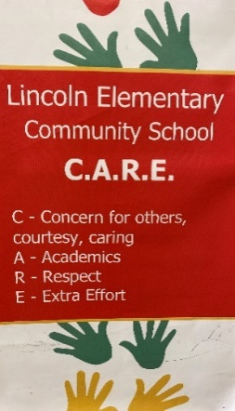
Students demonstrate good citizenship by fulfilling their civic and social responsibilities and contribute to the well-being of the communities in which they are a member (including their home, school, neighbourhood, country, and the greater world).

